* INTRODUCTION

Starting a new company can be an exciting and rewarding experience, but it also requires careful planning and analysis to ensure that the business is viable and successful. There are several key areas that you should focus on when conducting a startup company analysis. Conducting a thorough analysis of these areas can help you identify potential challenges and opportunities, and develop strategies to address them. It is also important to regularly review and update your analysis as the business progresses, in order to adapt to changing market conditions.

* PROBLEM DEFINITION & DESIGN THINKING

2.1 EMPATHY MAP

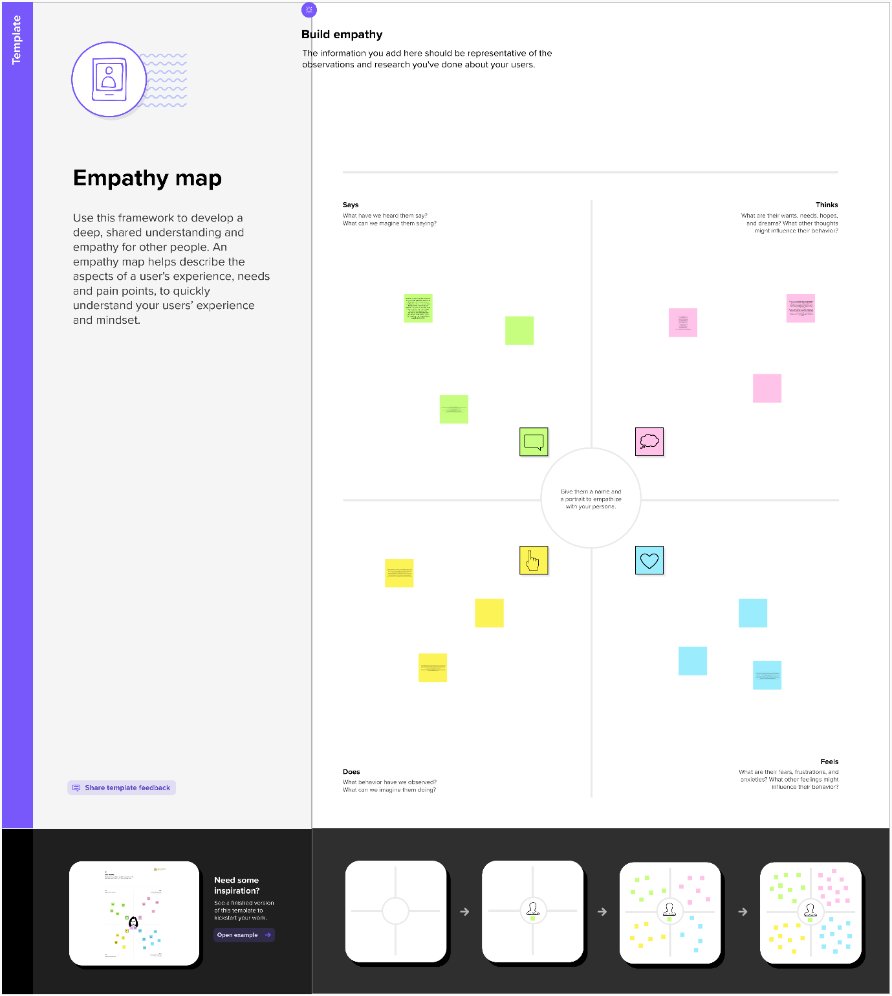

2.2 IDEATION &BRAINSTORMING MAP

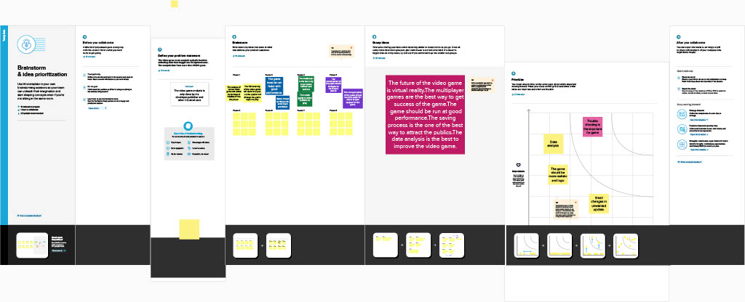

* RESULT

Dashboard

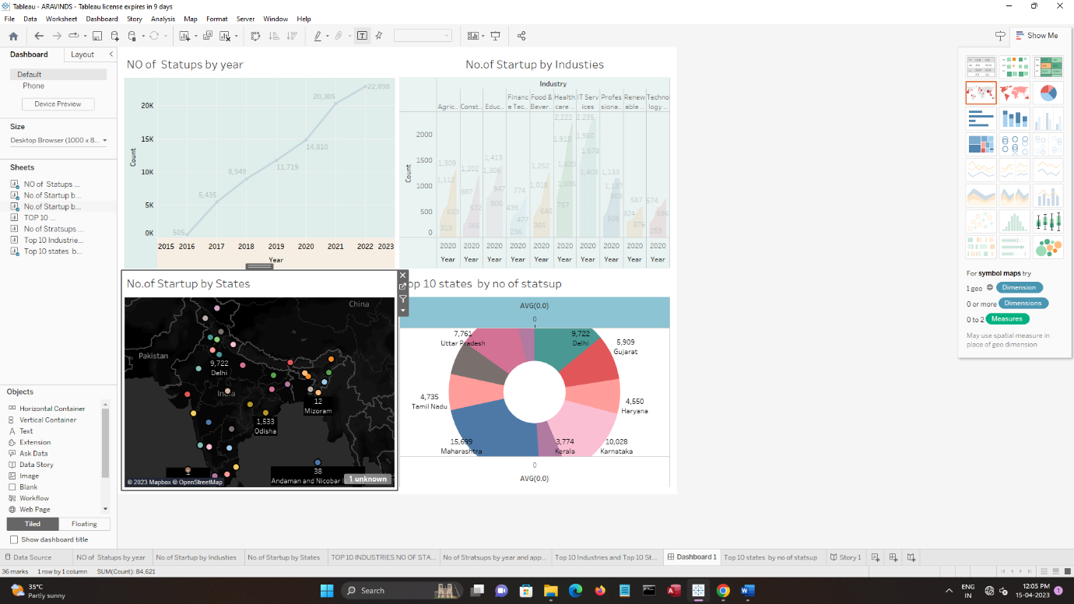

Story

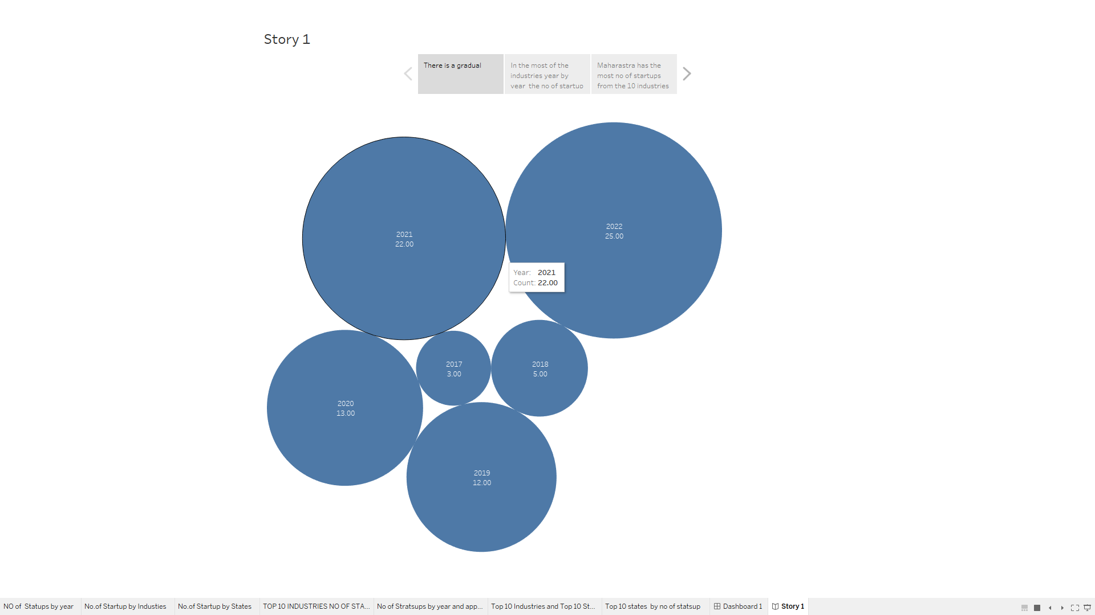

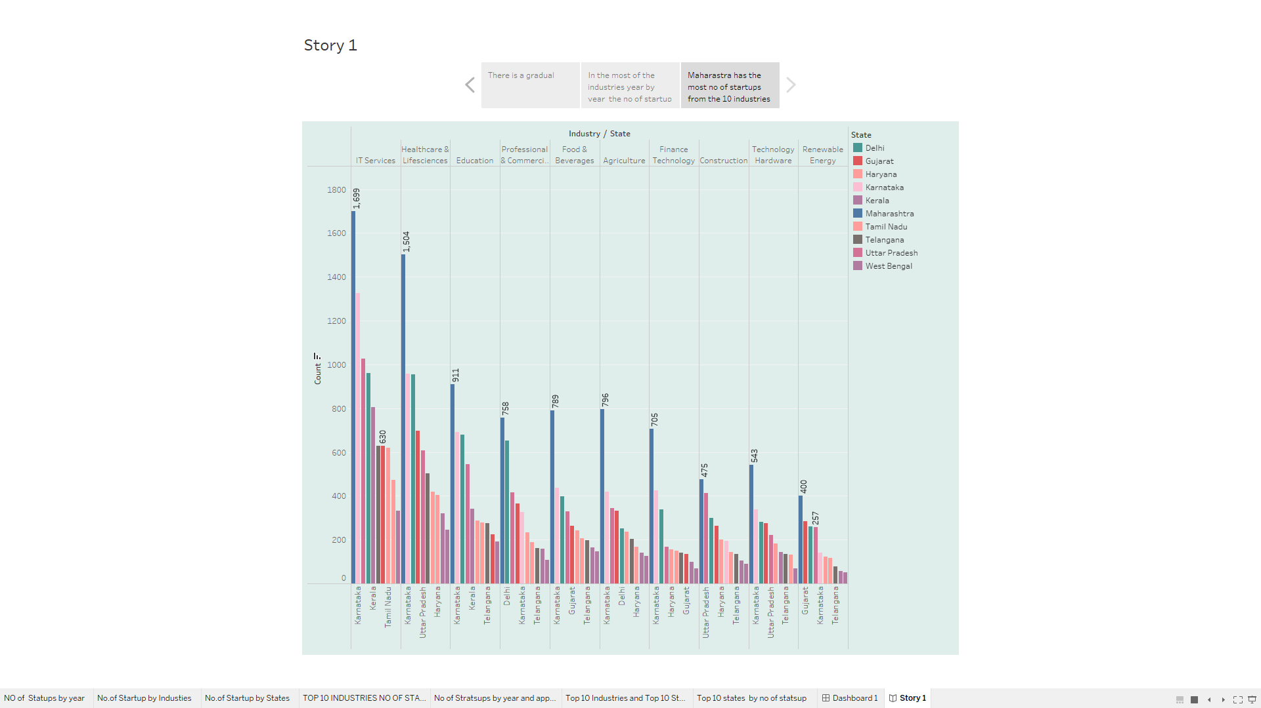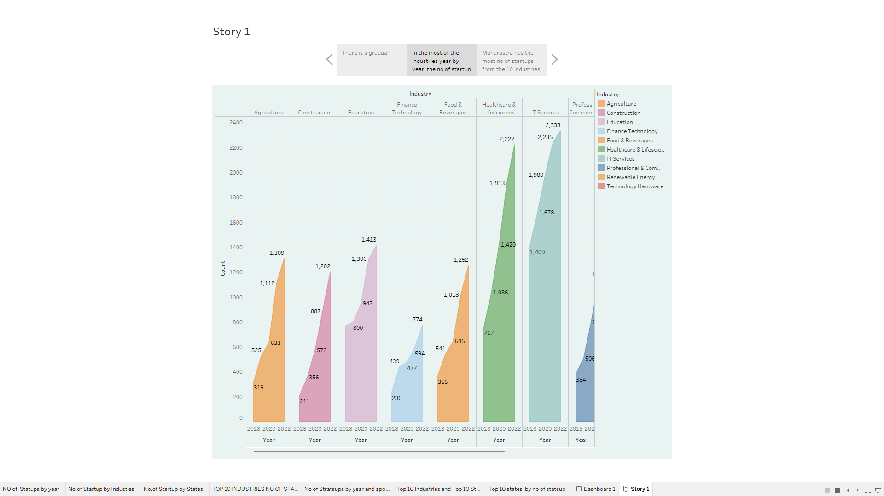

* ADVANTAGES

Startups are smaller and less structured. They are also innovative and keep improving their business models, processes, and portfolio. These allow them to adapt to disruptive technologies and changes in market conditions. Established competitors face vested interests, a historic path, and a strong team culture. This makes them resistant to change. Employees of large corporations get attracted by prestige and big salaries. They easily lose sight of the company’s vision, mission and values and the success of its customers. Startup employees form a close-knit community that shares passion, beliefs, and values. They must work together for the good of the company, its customers and the world at large.

* DISADVANTAGES

Most startups fail within their first year of operations, so the risk of failure is high. Working under such high risk can blur a startup’s strategic vision. So they either fail to seize market opportunities or overestimate their sales projections. High risk also hinders a startup’s ability to attract experienced and competent staff. It takes blood, sweat, and tears to build a company, and long working hours are the norm for startups. The rewards might be low since it takes time to generate revenue and make profits. Some startups give up since it’s demotivating to work without proper compensation.

* APPLICATIONS

Diagnostic analytics is used to distinguish which factors influence or contribute to current events and product performance in the market. If an organization loses its sales over a period of time, diagnostics analytics can help them analyze the reasons behind the loss and prevent such situations in the future. Similarly, the organization can easily and efficiently track the reasons and factors contributing to the success of a particular product and implement the same strategies in the future for other campaigns. Descriptive analytics uses the existing data of an organization to understand what events have occurred in the past, analyze current situations and follow the trajectory. It helps the organization perform the SWOT analysis, thereby improving its performance. This further enhances the accessibility of relevant information and patterns for the stakeholders and managers.

* CONCLUSION

Entrepreneurship is about solving problems and building new things. Entrepreneurship is important especially nowadays when we have to learn how to operate in an increasingly changing world. It includes both a mindset point of view, where problems are seen as opportunities and failures as learning experiences, and skills that help you learn to solve problems and build something new.

* FUTURE SCOPE

A good career means it depends on many factors and it also depends on an individual. Is business analysis a good career? If this question is in your mind, you’re in the right place. Considering the below mentioned basic parameters, yes, [business analysis,](https://iibmindia.in/apply-and-pay-online/executive-program-in-business-analytics/)[Online Certifications Courses  in India](https://iibmindia.in/) is  no doubt a promising career.

* APPENDIX

1. SOURCE CODE

DASHBOARD

<https://public.tableau.com/views/ARAVINDS1/Dashboard1?:language=en-GB&publish=yes&:display_count=n&:origin=viz_share_link>

Story

<https://public.tableau.com/views/ARAVINDS2/Story1?:language=en-GB&publish=yes&:display_count=n&:origin=viz_share_link>